**Object-Oriented Programming**

**WorkShop #37**

**DATE: 21/08/2023**

**NRC: 9652**

RUBRIC

Strategy pattern:.10

GUI/table:............10

MongoDB Collection:...10

working algorithms:.....10

Clean code/principles:.10

1. Calvache Gabriel

**RUBRIC**

**Killer:** César Galarza

**Total:** 48/50

Strategy pattern: 10/10

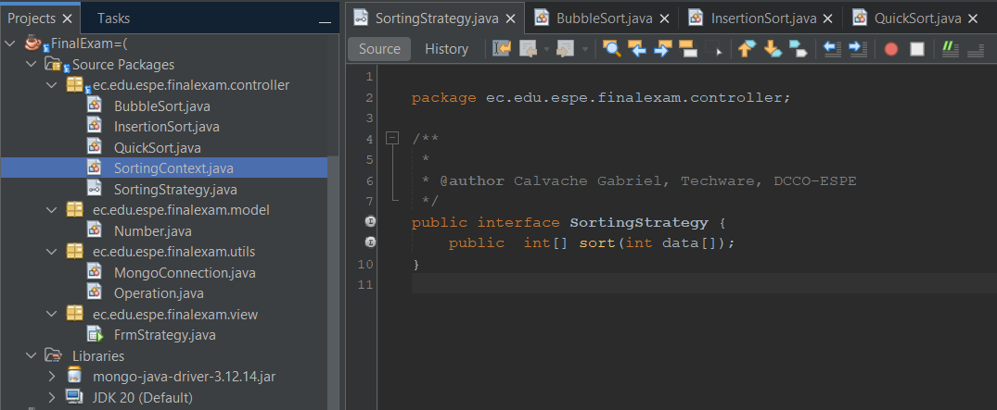

GUI/table: 10/10

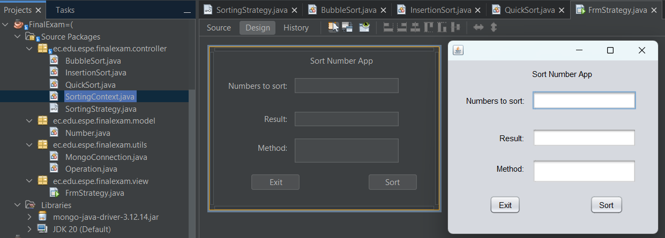

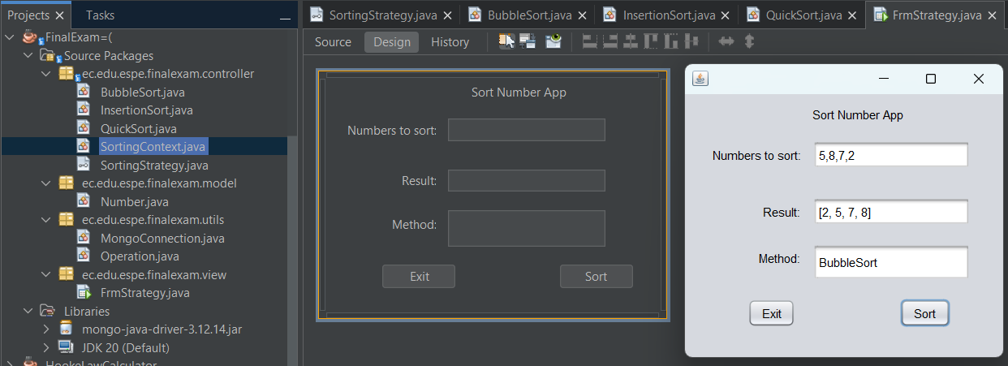

MongoDB Collection: 10/10

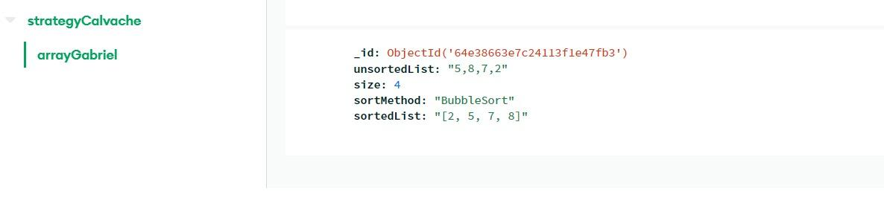

Working algorithms: 8/10

**BUBBLE**

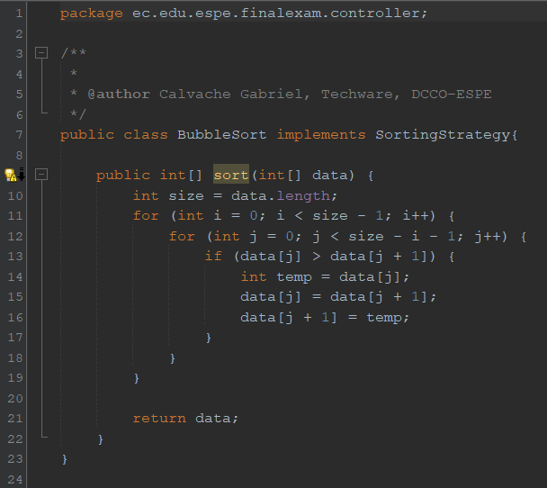

**INSERTION**

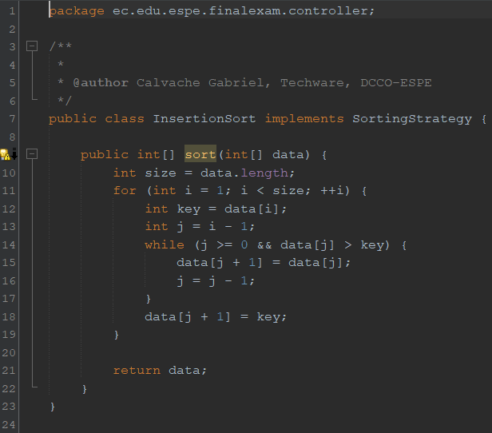

**QUICK**

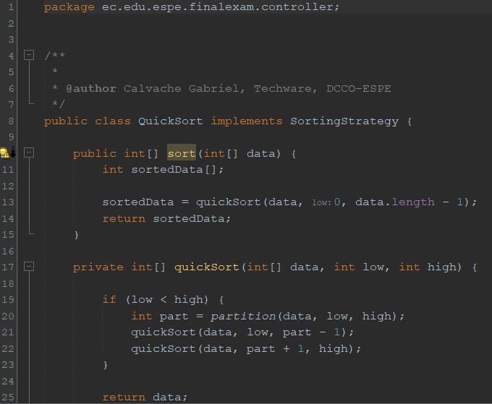

**EXCEPTIONS**

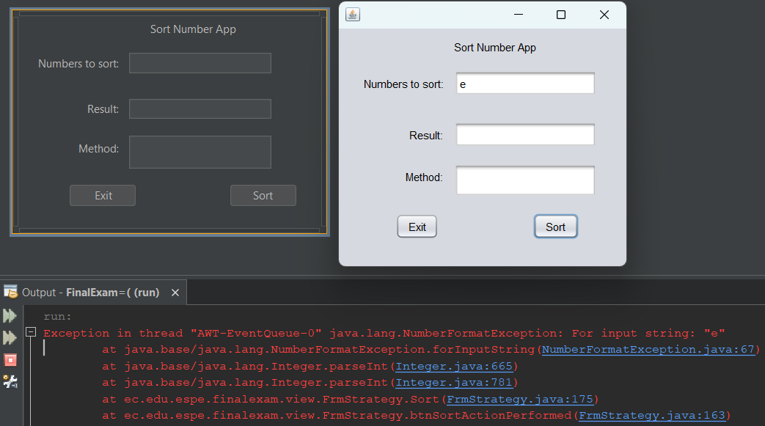

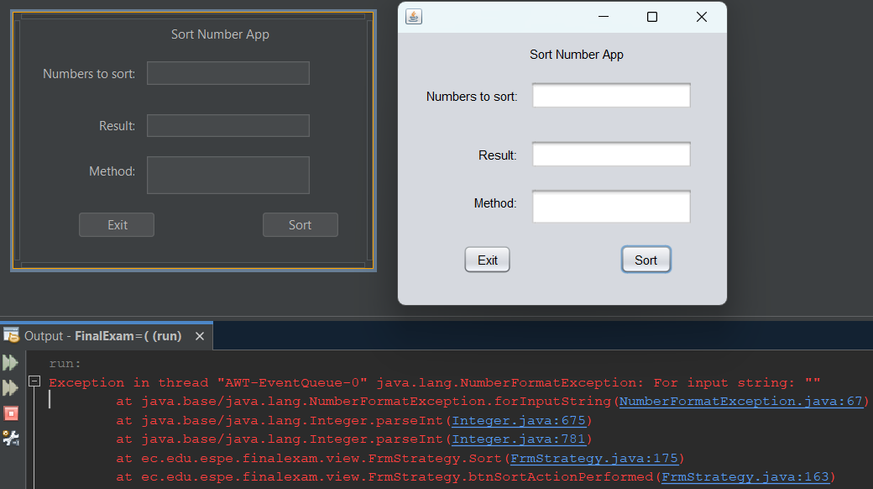

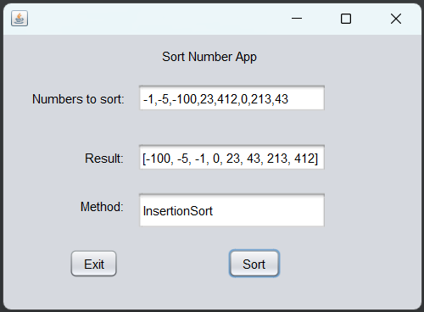

Clean code/principles:10/10

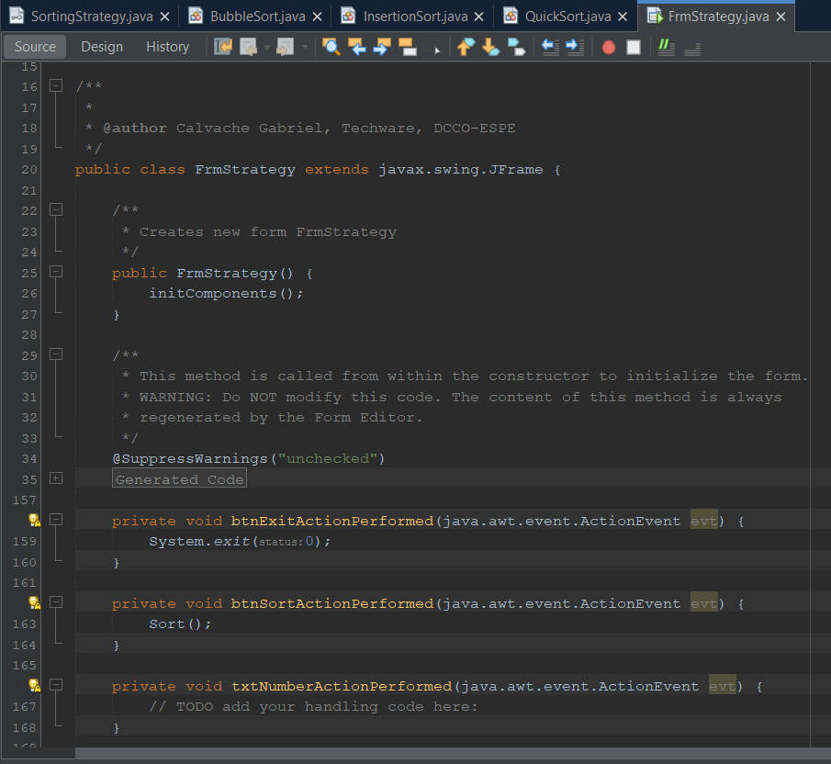

1. Casignia Diego

Total:49 /50

RUBRIC

Strategy patter: 10/10

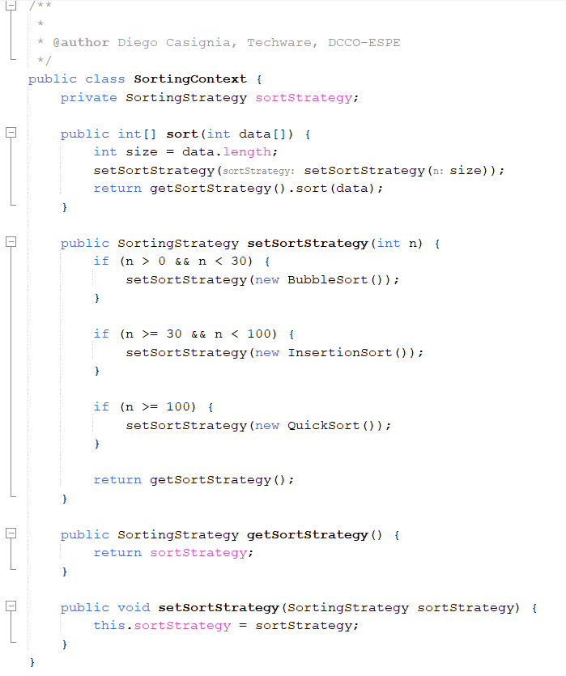

GUI/table: 9/10

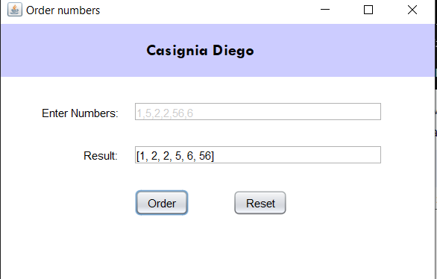

MongoDB Collection: 10/10

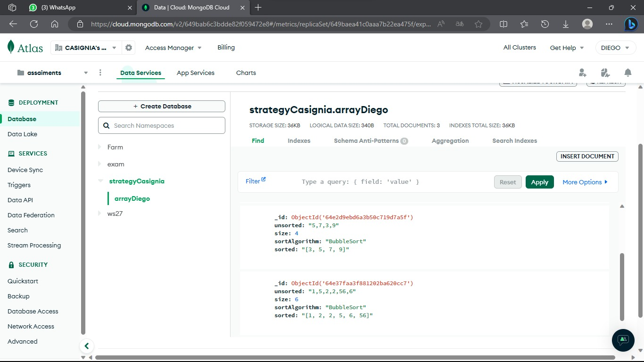

working algorithms: 10/10

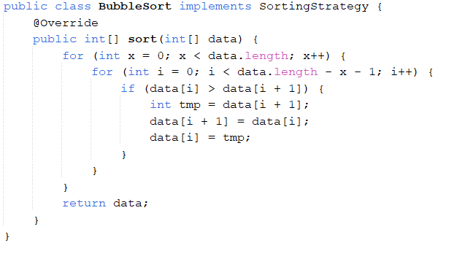

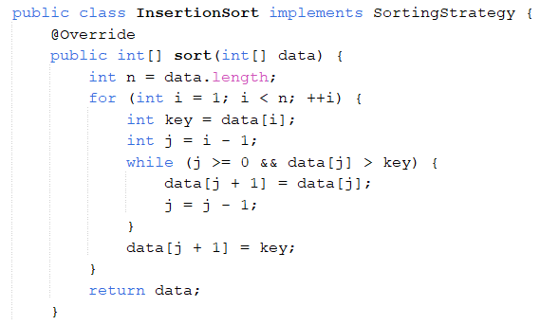

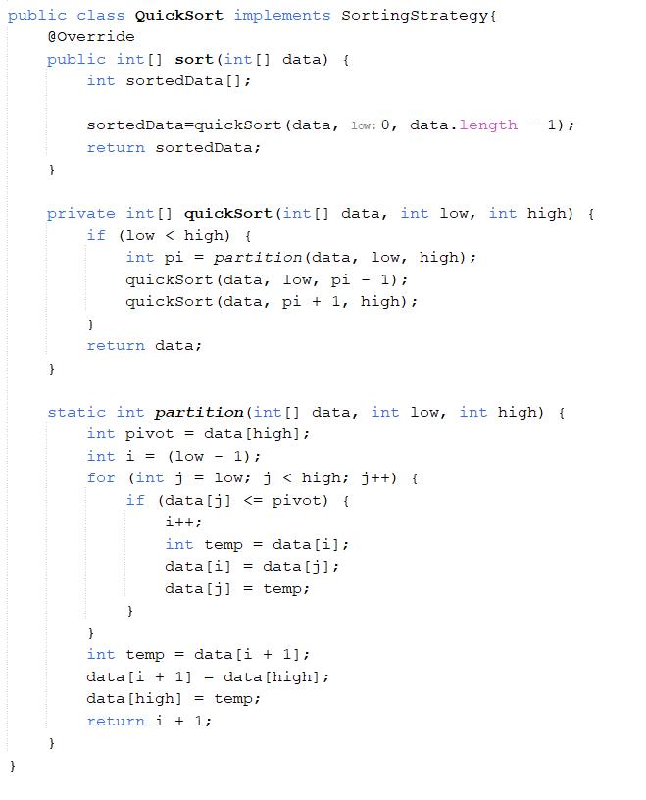

Clean code/principles: 10/10

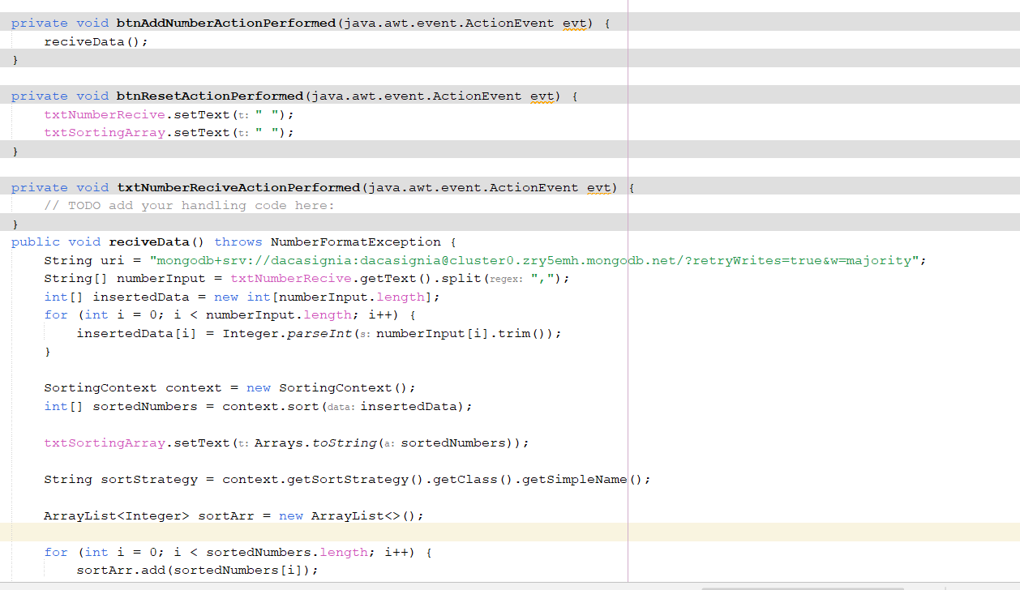

killer: Gabriel Calvache

1. Cedeño Rony
2. Galarza Luis TOTAL 49/50

RUBRIC

Strategy pattern:.10/10

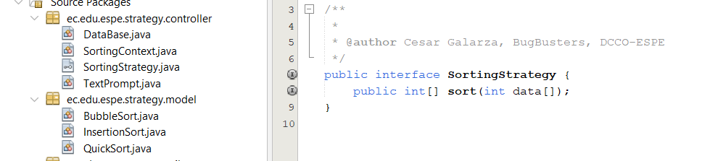

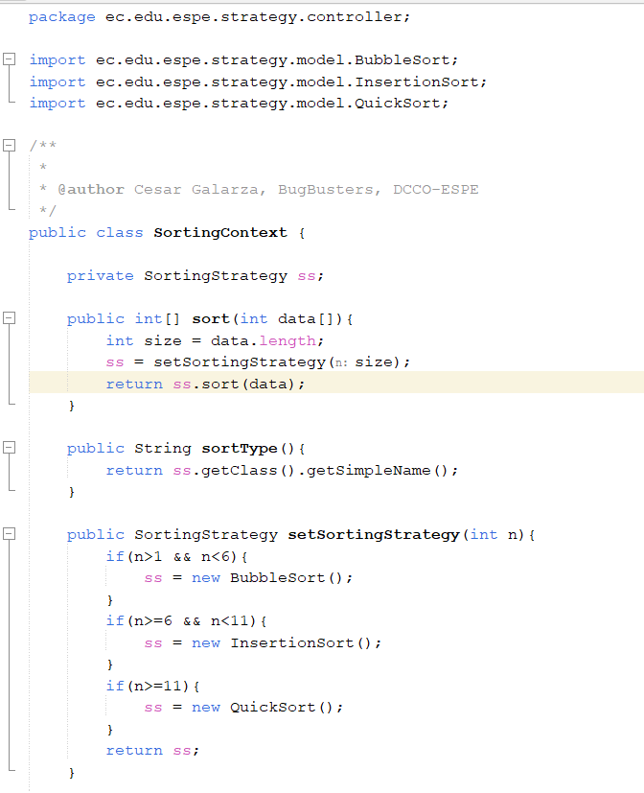

GUI/table:............10/10

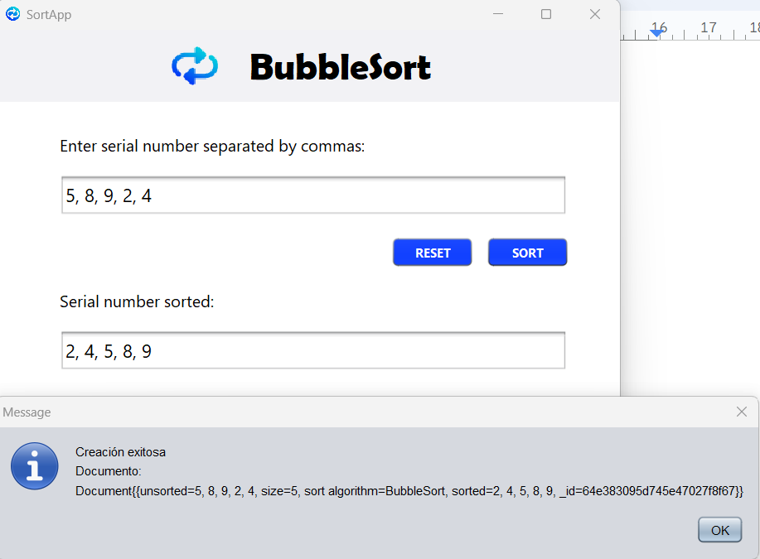

MongoDB Collection:...10/10

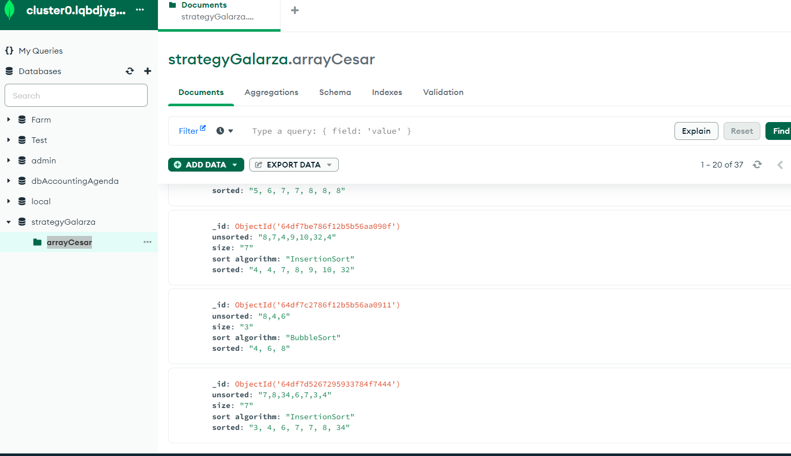

working algorithms:.....10



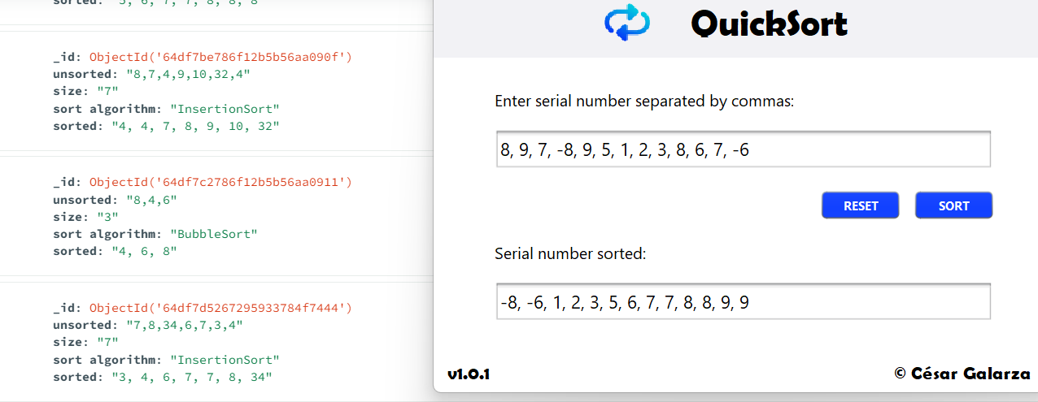

Clean code/principles:.9/10

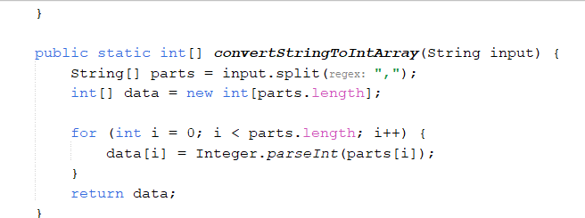

Killer: Juan Pasquel